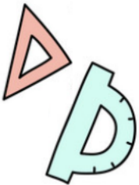
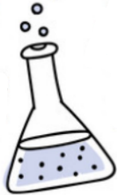




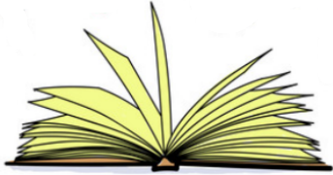
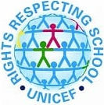
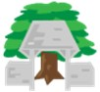
Other Subjects
Computing – understand how a
computer network can be used to share information, develop more efficient typing skills, an introduction to block coding,
PE – Netball skills, Dance - machines
Music – Creating industrial soundscapes, learning songs from Oliver
PSHE – Keeping healthy, including diet, exercise and sleep
Spanish – making about how someone is, Christmas
Revolution. The children will find out about the living and working conditions of people who worked in the steel industry in Victorian times.
We will then begin our new history theme looking at how people lived in prehistoric times.

Religious Education
The focus for this half term is Christianity and what it is like for someone to follow God. The children will look closely at the story of Noah. They will make links between the story and the idea of the covenant. They will also look at the promises that Christians make in
the wedding ceremony.
The themes for this half term are…
Local Study: What’s Through the Window?
What changed from the Stone Age to the Iron Age?
Enrichment Activities
12 & 13-11-25 Visits to Kelham Island Museum
10 & 11-12-25 Forest school sessions
17-12-25 RE Festival day – Christmas
14-12-25 Pantomime from a visiting theatre company
RRS
At the start of the half term, the children
will learn about democracy and will vote for a class representative for the School Council.
We will then develop our class charters with agreed actions that will help us to respect everyone’s rights.
Linked to our English and history work, we will be considering Articles 19 (protection from mistreatment), 20 (children without families), 27 (basic needs), 28 (education) and 32 (protection from harmful work) in particular.

History
For the first few weeks, we will focus on the steel industry in Sheffield. We will look at significant people in our steel history and how the city grew rapidly during the Industrial

Science

Our science topic is Animals including Humans.
The children will find out about:
Skeletons – comparing skeletons of different animals,
Vertebrates and invertebrates,
How muscles work,
Food groups and how they help our bodies to grow and stay healthy,
The Eatwell Plate for a balanced diet.

Maths
We will be working on addition and
subtraction, continuing with mental
methods and moving on to the standard
column methods. The children will model their calculations using base ten blocks and place value counters to help them to understand the procedures. They will also be learning the 4 times table. You can help at home by practising quick recall of the 4 times table facts and playing games that involve mental addition and subtraction of single-digit numbers (number bonds).
English
We will be using a version of Oliver Twist (Real Reads) to inspire the children this half term. This links to our history work on the Sheffield steel industry in Victorian times. The children will use their senses to write setting descriptions and will write recounts from different points of view.
The children will learn how to organise their writing into paragraphs considering changes in time, place, topic or person. They will use time adverbials to link their writing.
You can help at home by continuing to read
widely and look for ambitious vocabulary that
they may use in their writing.
Lydgate Junior School
Curriculum Overview
Year 3 Autumn term 2
Design Technology

Linked to our science topic, we will be looking at what makes a balanced diet. The children will look at food labels and consider how to make appropriate choices. They
will be designing their own jacket potato meal
that they will prepare and eat during
w/c 1-12-25

